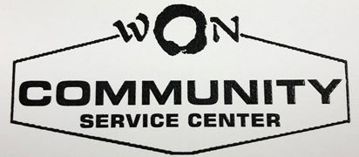
FREE ENGLISH AS A SECOND LANGUAGE CLASSES
FREE CITIZENSHIP CLASSES
BEGINNING FEBRUARY 7, 2019 6:30 -8:30 PM THURSDAYS ONLY
SEMESTER ENDS JUNE 20, 2019
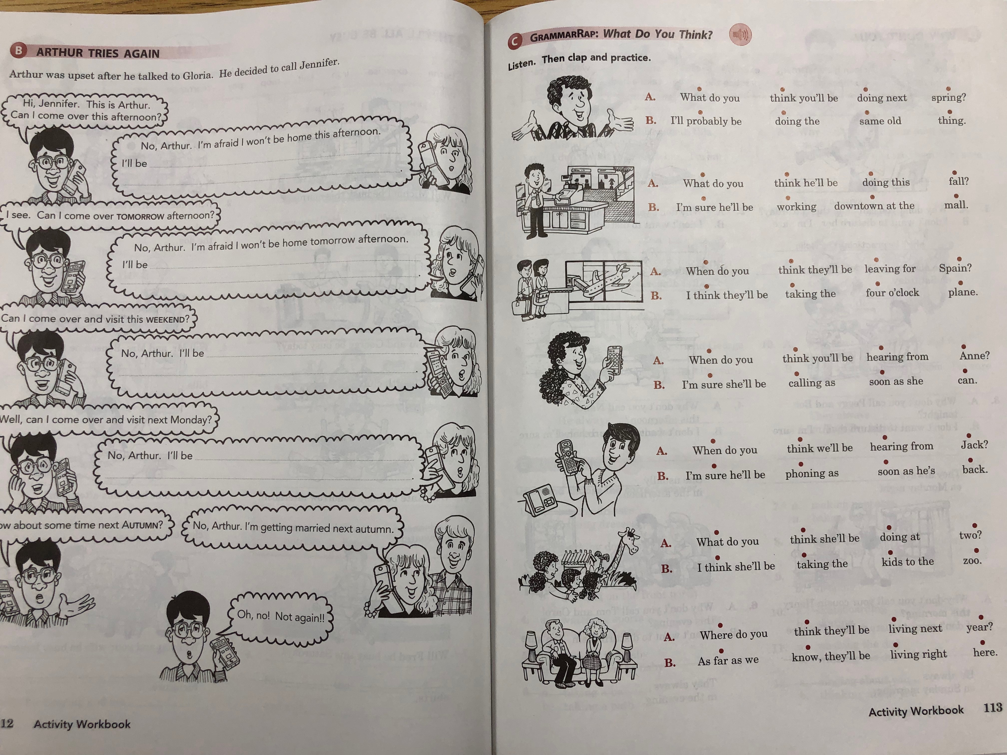
TUTORING UPON APPOINTMENT
REGISTRATION & TEXTBOOK FEE $50

WON COMMUNITY SERVICE CENTER
423 ABINGTON AVE GLENSIDE PENNSYLVANIA 19038-4801
(215) 884- 8443 bokhyae@woncommunity.org

